ASSIGNMENT -5

Relational and Logical Operators.
Q1) write a query that will give you all orders for more than Rs. 1000.
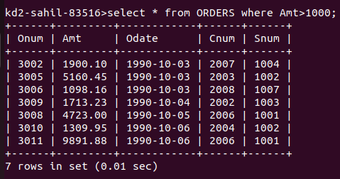

Q2) write a query that will give you the names and cities of all the salespeoples in London with a Commission above the .10
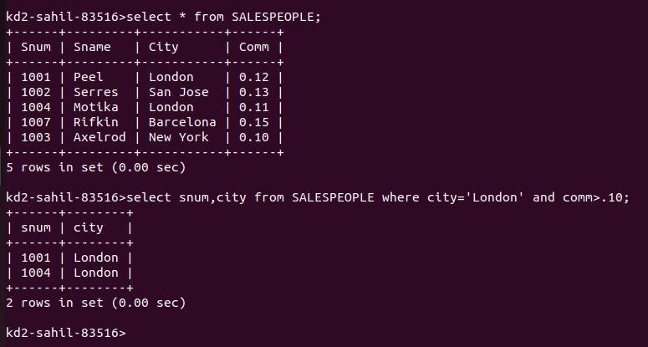

Q3) write a query on the customers table whose output will exclude all the customers with a rating <= 100, unless they are located in Rome.

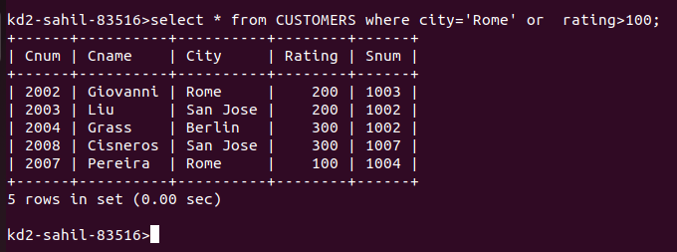

Q4) What will be the output from the following query?
select * from Orders
where (amt < 1000 OR
NOT (odate = ‘1990-10-03’ AND cnum > 2003) );

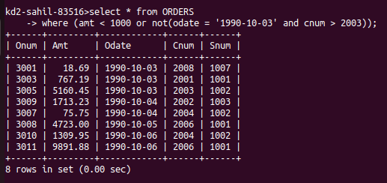

Q5) What will be the output of the following query?
Select * from Orders
where NOT ((odate = ’1990-10-03’ OR snum>1006) AND amt >= 1500);
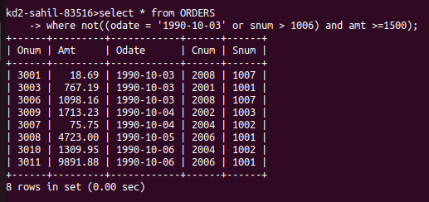

Q6) what is asimpler way to write this query?
Select snum,sname,city,comm from Salespeople
where (comm > .12 OR comm <.14);

